Support Questions
- For each of the following equations state whether the parabola would open up or down.

a. $y=3(x-1)^{2}+2$
The value of “a” in the equation is 3. It is positive, the parabola opens up.
b. $y=-(x+3)^{2}$
The value of “a” in the equation is -1. It is negative, the parabola opens down.
c. $y=x^{2}+5$
The value of “a” in the equation is 1. It is positive, the parabola opens up.
d. $y=-x^{2}$
The value of “a” in the equation is -1. It is negative, the parabola opens down
e. $y=-1(x+2)^{2}+1$
The value of “a” in the equation is -1. It is negative, the parabola opens down
f. $y=3(x-4)^{2}-2$
The value of “a” in the equation is 3. It is positive, the parabola opens up.
Support Questions
- For each of the following equations state the value of “h” and describe the shifting of the function.
When an equation of a parabola is in vertex form $y=a(x-h)^{2}+k$ the value of h shifts the function left if the value is positive and right if the value is negative.

a. $y=3(x-1)^{2}+2$.h =-1, it is negative, then the function will shift left -1units. When -1 is substituted into the equation $y=a(x-h)^{2}+k$the value of “h” appears to be positive but this is only because of the two negative signs converting the negative sign to a positive value
b. $y=-(x-3)^{2}$, h =-3, it is negative, the function shifts to the left 3 units.
c. $y=x^{2}+5$
h = 0 therefore there is no shift
d. $y=-x^{2}$
h = 0 therefore there is no shift

e. $y=-1(x-2)^{2}+1$
h=-2 it is negative, then the function will shift left -2 units. When -2 is substituted into the equation $y=a(x-h)^{2}+k$the value of “h” appears to be positive but this is only because of the two negative signs converting the negative sign to a positive value.
f. $y=3(x-4)^{2}-2$
h= -4 it is negative, then the function will shift left -4 units. When -4 is substituted into the equation $y=a(x-h)^{2}+k$the value of “h” appears to be positive but this is only because of the two negative signs converting the negative sign to a positive value.

- Graph $y=x^{2}$ with each of the functions given below: a. $y=(x+4)^{2}$
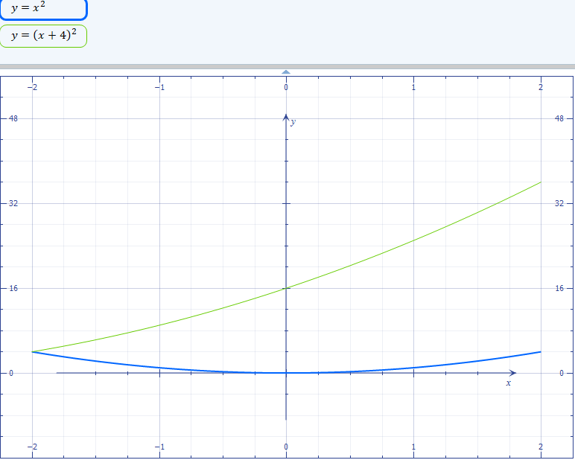

b. $y=(x-1)^{2}$
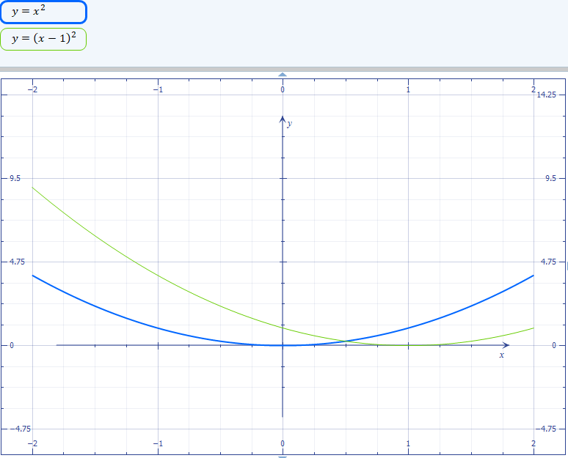
c. $y=-(x+2)^{2}$
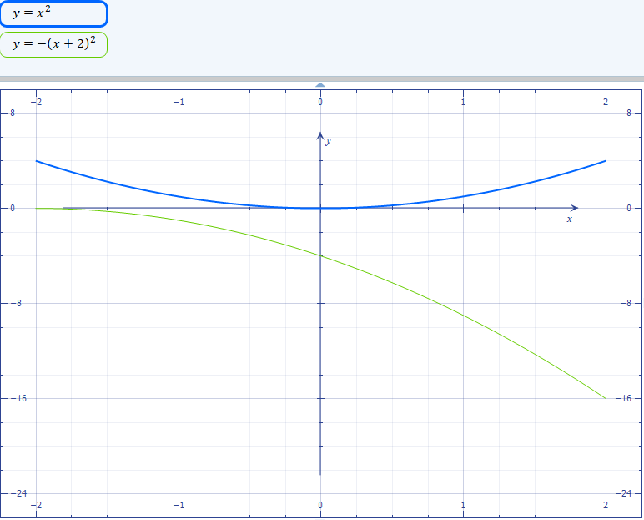

$$y=a(x-h)^{2}+k$$
Support Questions
- For each of the following equations state the value of “k” and describe the shifting of the function.

When an equation of a parabola is in vertex form $y=a(x-h)^{2}+k$ the value of k shifts the function up if the value is positive and down if the value is negative.

a. $y=3(x-1)^{2}+2$
Solution

k = 2 then the function will shift up 2 units
b. $y=-(x-3)^{2}$
Solution
k = 0 then the function does not shift
c. $y=x^{2}+5$
k = 0 then the function does not shift
d. $y=-x^{2}$ , k = 0 then the function does not shift
e. $y=-1(x-2)^{2}+1$ , k = 1 ,its positive then the function will shift up 1 units
f. $y=3(x-4)^{2}-2$,, k = -2 ,its negative then the function will shift down 2 units
- Graph $y=x^{2}$ with each of the functions given below:

a. $y=x^{2}-3$
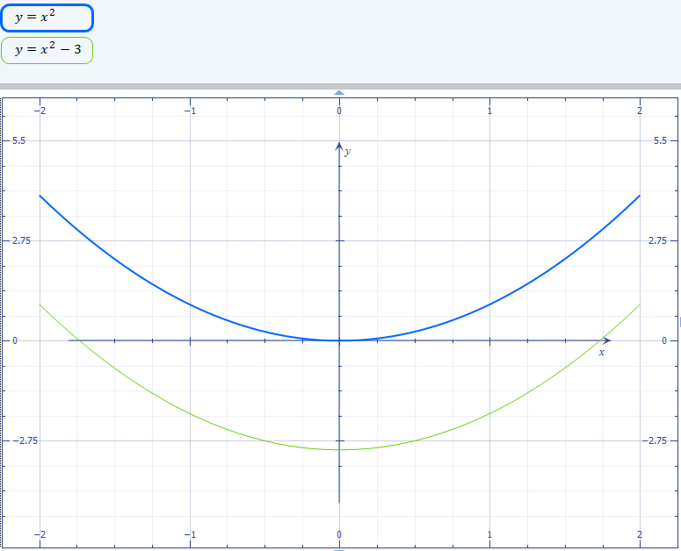

b. $y=x^{2}+2$
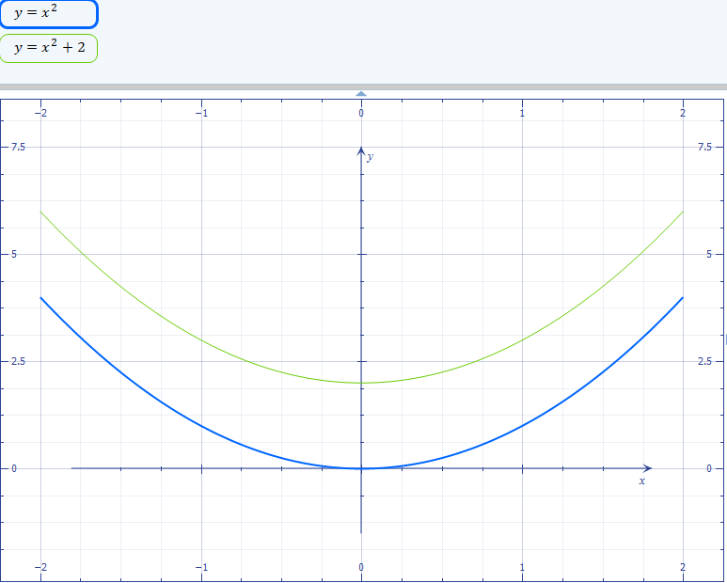

c. $y=-x^{2}-1$
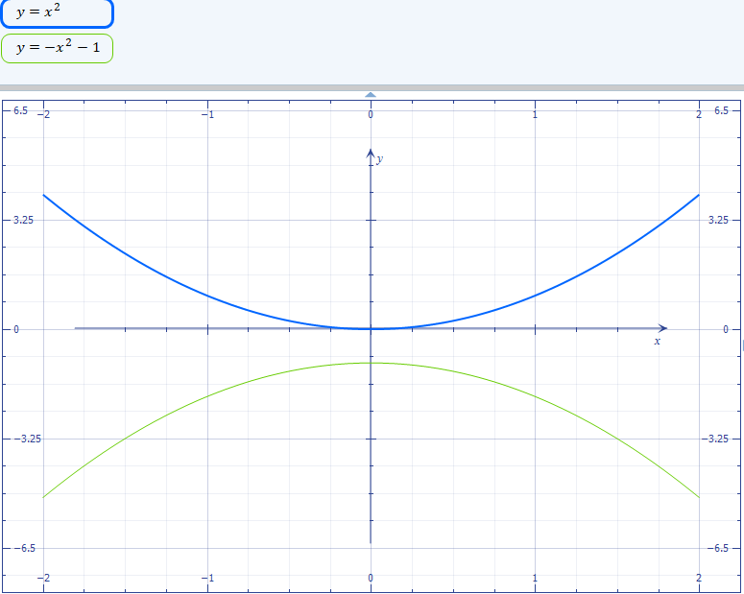 Key Question #1
- For each of the following equations state whether the parabola would open up or down.
a. $y=(x-1)^{2}+2$
The value of “a” in the equation is 1. It is positive, the parabola opens up
b. $y=-(x-3)^{2}$
The value of “a” in the equation is -1. It is negative, the parabola opens down.
c. $y=x^{2}+5$
The value of “a” in the equation is 1. It is positive, the parabola opens up
d. $y=-x^{2}$
The value of “a” in the equation is -1. It is negative, the parabola opens down.
e. $y=-1(x-2)^{2}+1$
The value of “a” in the equation is -1. It is negative, the parabola opens down.
f. $y=3(x-4)^{2}-2$
The value of “a” in the equation is 3. It is positive, the parabola opens up
- For each of the following equations state the value of “h” and describe the shifting of the function.
a. $y=3(x-1)^{2}+2$
. $y=3(x-1)^{2}+2$.h =-1, it is negative, then the function will shift left -1units. When -1 is substituted into the equation $y=a(x-h)^{2}+k$the value of “h” appears to be positive but this is only because of the two negative signs converting the negative sign to a positive value
b. $y=-2(x-3)^{2}$
h =-3, it is negative, then the function will shift left 3 units. When -3 is substituted into the equation $y=a(x-h)^{2}+k$the value of “h” appears to be positive but this is only because of the two negative signs converting the negative sign to a positive value
c. $y=-(x-4)^{2}-2$
h =-4, it is negative, then the function will shift left 4units.
d. $y=(x-2)^{2}+1$
h =-2, it is negative, then the function will shift left 2units.
e. $y=-x^{2}-5$
-(x^2-5)
h =-5, it is negative, then the function will shift left 5 units
f. $y=x^{2}-3$
h =-3, it is negative, then the function will shift left 3 units

- Graph $y=x^{2}$ and each of the functions given below:

a. $y=(x-1)^{2}$

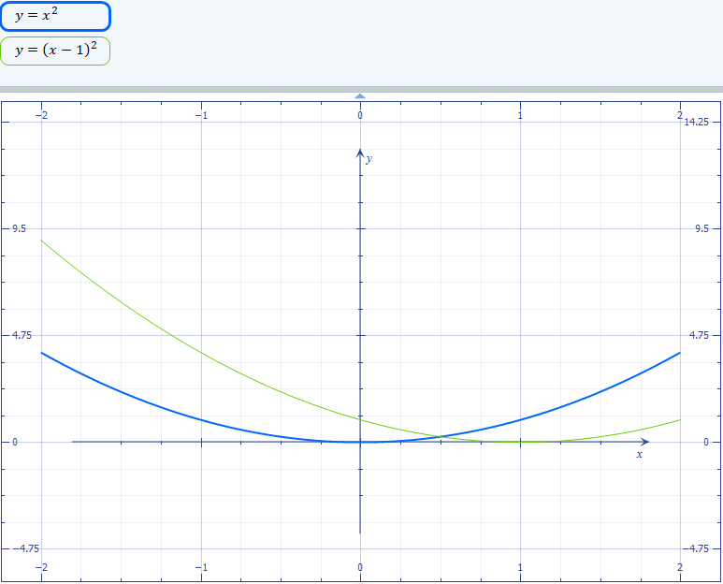

b. $y=-(x+7)^{2}$
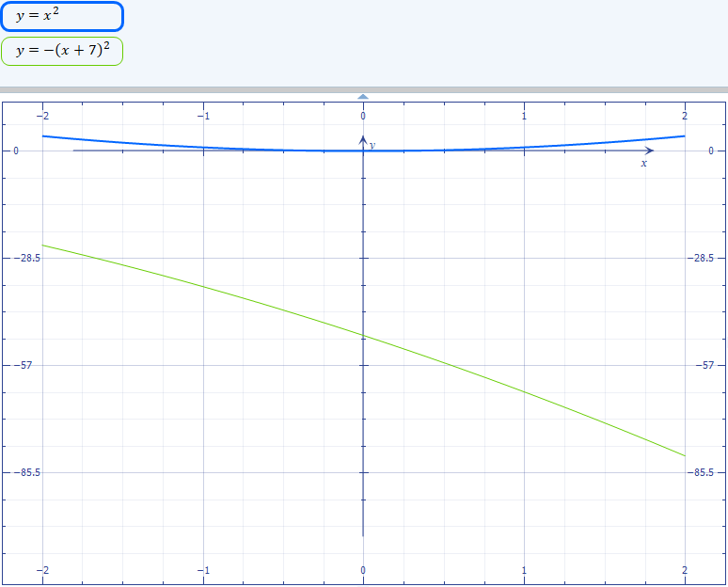

c. $y=-(x-3)^{2}$
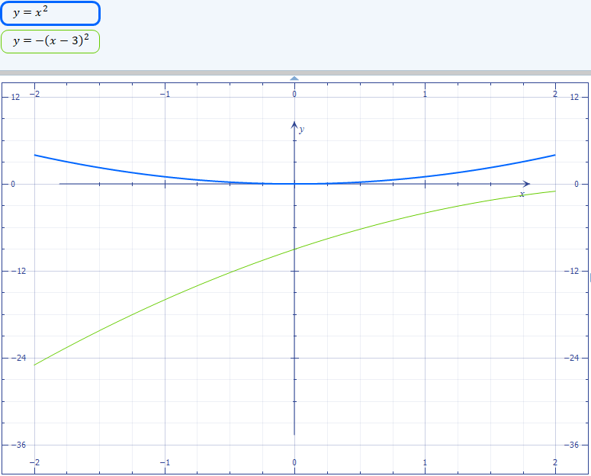

- For each of the following equations state the value of “k” and describe the shifting of the function.
$y=a(x-h)^{2}+k$ the value of k shifts the function up if the value is positive and down if the value is negative.
a. $y=3(x-1)^{2}-3$
k = -3 ,its negative then the function will shift down 3 units
b. $y=-(x-3)^{2}+2$
k = 2 ,its positive then the function will shift up 2 units
c. $y=-x^{2}$
k = 0 then the function does not shift
d. $y=x^{2}+5$
k = 0 then the function does not shift
e. $y=-1(x-2)^{2}$ k = 0 then the function does not shift
f. $y=3(x-4)^{2}+1$
k = 1, its positive then the function will shift up 1 units
Key Question #1 (con’t)
- Graph $y=x^{2}$ and each of the functions given below:

a. $y=x^{2}+7$
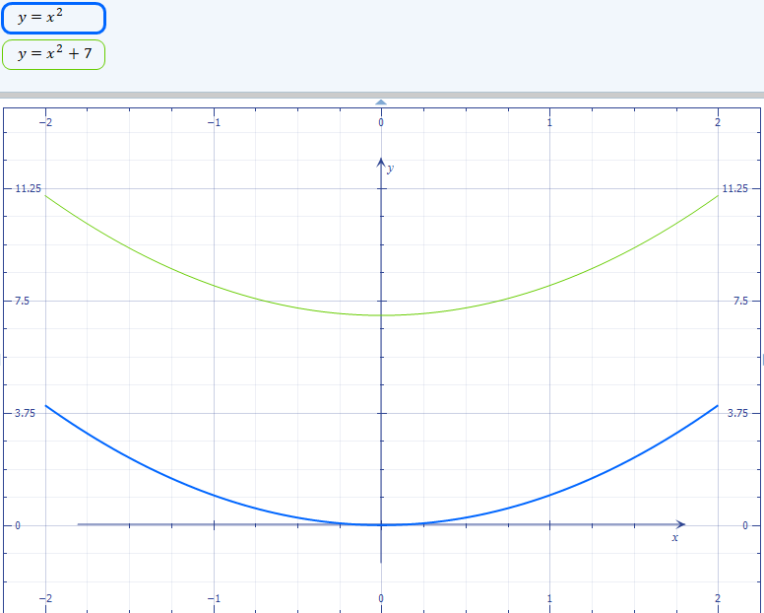

b. $y=x^{2}-3$
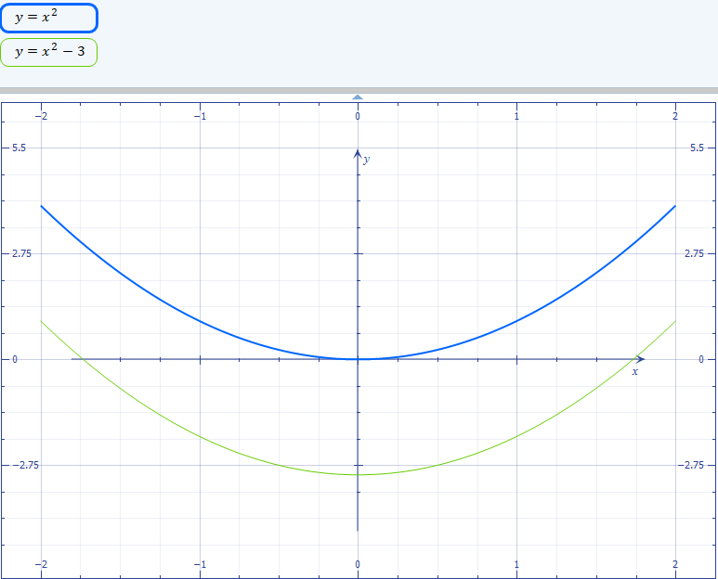

c. $y=-x^{2}+1$
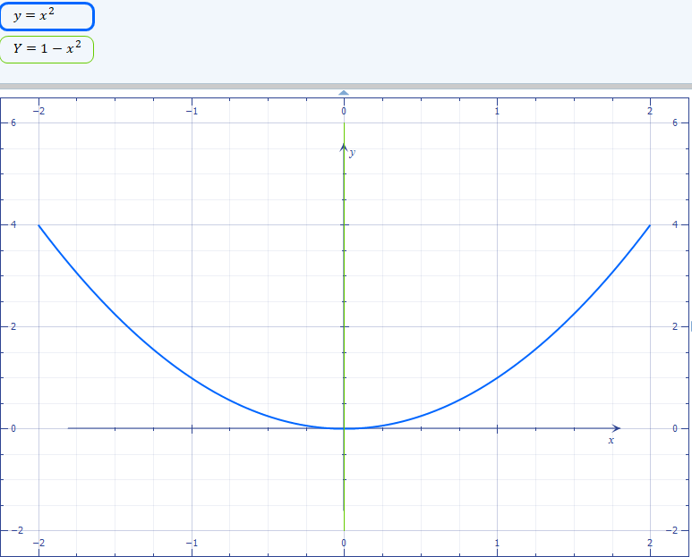
- For each of the following functions describe the transformation on $y=x^{2}$.

a. $y=(x-1)^{2}+2$
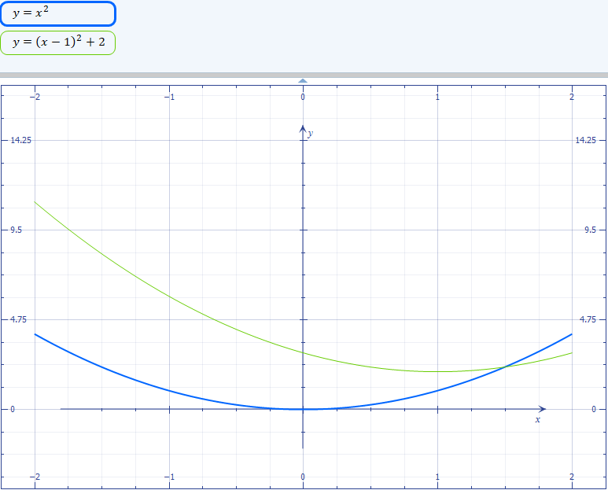

b. $y=-(x-3)^{2}$
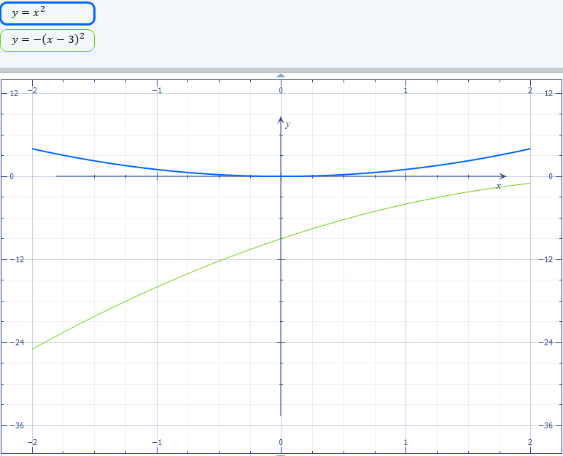

c. $y=x^{2}+5$
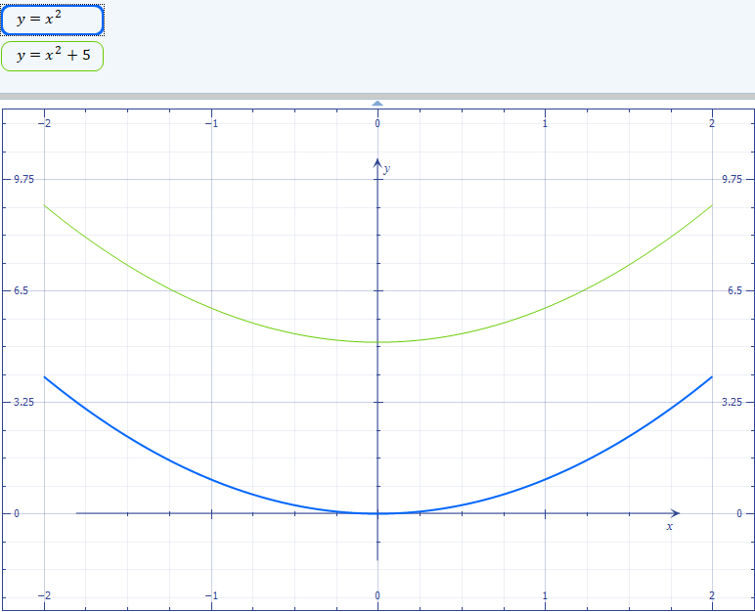

Solution

k = 5 then the function will shift up 5 units.

d. $y=-x^{2}$
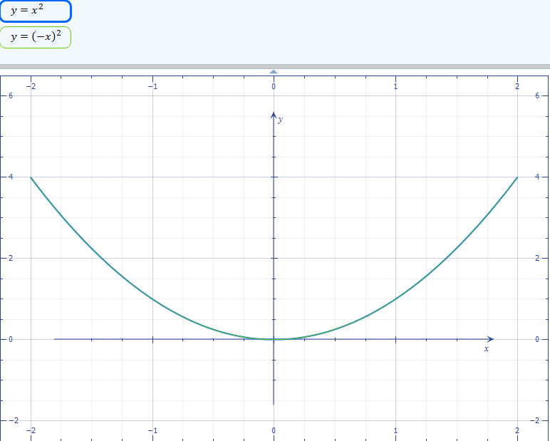

k = 0 then the function does not shift, it remains static.

e. $y=-1(x-2)^{2}+1$
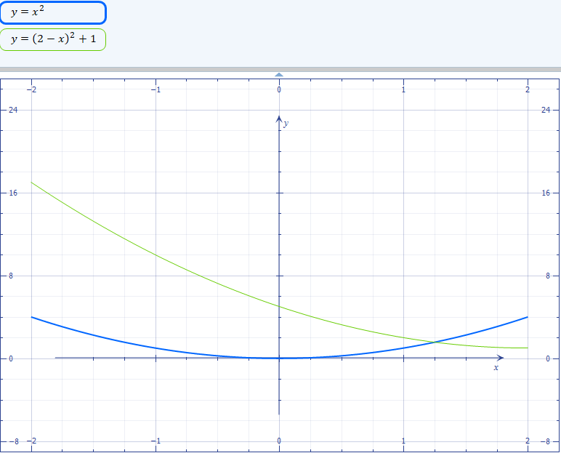

f. $y=3(x-4)^{2}-2$
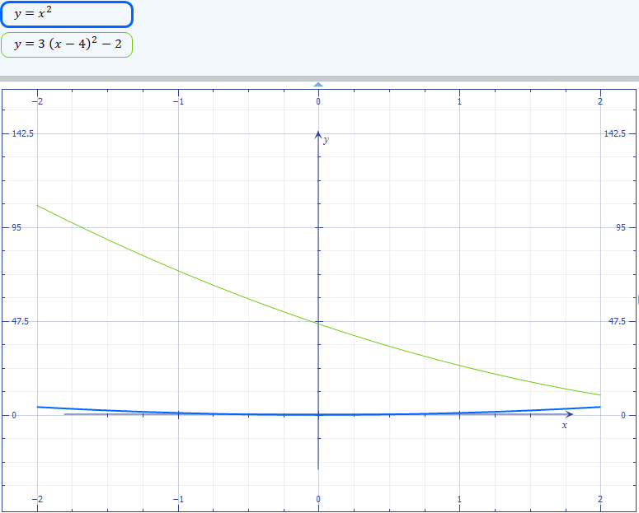

- The path of a cliff diver as he dives into a lake, is given by the equation $y=-(x-10)^{2}+75$, where y metres is the diver’s height above the water and, x metres is the horizontal distance travelled by the diver. What is the maximum height the diver is above the water?



$y=-(x-10)^{2}+75$, the parabola opening downward, v(10,75)maximum point
The maximum height the diver’s height above the water is 75 meters.

Support Questions
- Simplify each polynomial by using the distributive law.
- 4(2w + 5)
=4(2w)+4(5)
=8w+20
- 5x(-3x – 7)
=5x(-3x) +5x( -7)
=-15x^2-35x
- 2y (-4y + 8)
=2y(-4y)+2y(8)
=-8y^2+16y
=16y-8y^2
- –(3x + 4)
=-1(3x)+-1(4)
=-3x-4
e. –6x (-x + 2)
=-6x(-x)-6x(2)
=6x^2-12x
Support Questions
Directions: Expand and simplify each expression
2.a. (x + 3)(x - 4)=x(x-4)+3(x-4)
=x^2-4x+3x-12
= $x^{2}-x-12$
b. (2y - 3)(7y - 1) =2y(7y-1)-3(7y-1)
= $14y^{2}-23y+3$

c. (-t - 5)(t + 2) =-t(t+2)-5(t+2)
= $-t^{2}-7t-10$

d. (3x + 1)(2x - 9) =3x(2x-9)1(2x-9)
=$6x^{2}-25x-9$

e. (7w - 3)(5w + 6) =7w(5w+6)-3(5w+6)
=$35w^{2}+27w-18$
f. (x - 5)$2$ =(x-5)(x-5)
=x(x-5)-5(x-5)
=$x^{2}-10x+25$

g. (4n – 2)$2$ =(4n-2)(4n-2)
=4n(4n-2)-2(4n-2)
= $16n^{2}-16n+4$
h. (-7s –3)(s + 1) =-7(s+1)-3(s+1)
=$-7s^{2}-10s-3$
- a. 5(3y – 2)(y+7)
=5[(3y – 2)(y+7)]
=(3y(y+7)-2(y+7)
=5[$3y^{2}+19y-14$]
=$15y^{2}+95y-70$
b. –2(y – 3)(5y – 6) =(-2y-5) (5y-6)
=2y(5y-6)-5(5y-6)
=$-10y^{2}+42y-36$
c. 6(4x + 3)(5x – 2) =(24x+18)(5x-2)
=24x(5x-2)18(5x-2)
=$120x^{2}+42x-36$
4.a. (x – 2y)(3x + 5y) =x(3x+5y)-2y(3x+5y)
=$3x^{2}-xy-10y^{2}$

b. (-x + 3w)(w – 1) =-x(w-1)+3w(w-1)
=$-wx+x+3w^{2}-3w$
c. –8(3w – 7y)(2w + y)=(-24w+56y)(2w+y)
=$56y^{2}+88wy-48w^{2}$
- a. –(x + 4)$2$ = -[(x+4)(x+4)]
=-1{$x^{2}+8x+16$}
=$-x^{2}-8x-16$
b. 3x + (2x – 3)(x + 5) = 3x+[2x(x-5)-3(x+5)]
=3x+[$2x^{2}+7x-15]$
= $2x^{2}+10x-15]$
c. -y(2y + 4x)(y - x)=-y[2y(y-x)+4x(y-x)]
=-y [$2y^{2}+2xy-4x^{2}$]
=-$2y^{3}+2x{ y}^{2}-4{yx}^{2}$

Support Questions
6 Factor completely
a. $c^{2}+3c+2$
a=1 c=2 =$\left(c + 1\right)\left(c + 2\right)$
b. $x^{2}+2x- 15$
a=1,c=-15,roots are -3 and 5
= $\left(x -3\right)\left(x + 5\right)$
c. $g^{2}+5g+4$
a=1,c=4
=$\left(g + 1\right)\left(g + 4\right)$
d. $x^{2}+3x- 18$= a=1,c=-18
=$\left(x -3\right)\left(x + 6\right)$
e. $r^{2}-6r+9$=a=1, c=9
=(r-3)(r-3)
f. $f^{2}-2f- 8$= a=1,c=-8
=$\left(f -4\right)\left(f + 2\right)$

g. $m^{2}+6m+9$=a=1.c=9
= (m+3)(m+3)
h. $5n^{2}-25n- 70$
a=5,c=-70
=$5\left(n -7\right)\left(n + 2\right)$
i. $3b^{2}-24b+45$
a=3,b=-24,c=45
=$3\left(b -5\right)\left(b -3\right)$
Key Question #2
- a. (x - 6)(x - 7)
=x(x-7)-6(x-7)
=$x^{2}-13x+42$
b. (4y - 5)(8y + 3) =4y(8y+3)-5(8y+3)
=$32y^{2}-28y-15$
c. (-x + 7)(x - 2) =-x(x-2)7(x-)
=$-x^{2}+9x-14$
d. (3y + 1)(y - 4) =3y(y-4)1(y-4)
=$3y^{2}-11y-4$
2.a. 2(5y – 1) (y - 3) =2[(5y-1)(y-3)]
2[$5y^{2}-16y+3$]
=$10y^{2}-32y+6$
b. –(y - 3)(2y – 5) =-1[ (y - 3)(2y – 5) ]
=-1[$2y^{2}-11y+15$]
=$-2y^{2}+11y-15$
c. 3(2x - 5)(3x + 1) =3[(2x - 5)(3x + 1) ]
=3[$6x^{2}-13x-5]$
=$18x^{2}-39x-15$
- a. (x – y)(x + 2y)
=x(x+2y)-y(x+2y)
=$x^{2}+xy-2y^{2}$
b. (-w + 2x)(w - 8)
= -w(w-8)2x(w-8)
=$2wx-16x-w^{2}+8w$
c. –8(3s – 4r)(9s + r)

=-8[(3s – 4r)(9s + r)]
=$32r^{2}+264rs-216s^{2}$
- a. –(x - 3)$2$ =-1[(x-3) (x-3)]
=$-x^{2}+6x-9$
b. 7x - (x – 4)(-x -3) =7x-[ (x – 4)(-x -3) ]
=7x-[ $12+x-x^{2}$]
=$x^{2}+6x-12$
c. -d(2d - 1p)(-3d - p)
=-d[(2d - 1p)(-3d - p)]
=2d(-3d-p)-p(-3d-p)
=-6d^2-2dp+3dp+p^2
=-d[-d^2+dp+p^2]
-d[$-d^{2}+dp+p^{2}$]
=$d^{3}-d^{2}p-{dp}^{2}$
- Write a simplified expression for the area of each object given below.

a)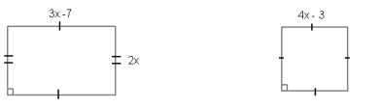b)
a)(3x-7)(2x) b)(4x-3) (4x-3)
=2x(3x-7) =4x(4x-3)-3(4x-3)
=$6x^{2}-14x$ = $16x^{2}-24x+9$

- Given the expression $(\text{3s}-4)(\text{4s}+5)$, explain in words the steps taken to completely simplify the expression
Open the brackets 3s(4s+5) -4(4s+5)
Simplify= $12s^{2}+15s-16s-20$
Collect the like terms = $12s^{2}-s-20$
- Directions: Fill in the missing terms
a)(m+3)(m+2)=m(m+2)3(m+2)
=$m^{2}+2m+3m+6$
b)(y-2)(y+1)=y(y+1)-2(y+1)
=$y^{2}+y-2y-2$
C)(x+4)(x-3)=x(x-3)4(x-3)
=$x^{2}-3x+4x-12$
d)(w-5)(w-2)=w(w-2)-5(w-2)
=$w^{2}-2w-5wx+10$
- Directions: Factor completely

a. $c^{2}+4c+4$
a=1 c=4 =(c+2)(c+2)
b. $x^{2}-2x- 8$
a=1,c=-8 b=-2 sum=-4+2=2,product -4*2=-8
=$\left(x -4\right)\left(x + 2\right)$
c. $g^{2}+8g+12$
a=1,b=8,c=12 s=6+2=8,p=6*2=12
=$\left(g + 2\right)\left(g + 6\right)$
d. $x^{2}-7x- 18$
a=1,b=-7,c=-18 s=-9+2= -7,p=(-9*2)= -18
=$\left(x -9\right)\left(x + 2\right)$
e. $r^{2}+10r+9$
a=1,b=10,c=9 s=-9+1= 10,p=(1*9)= 9
=$\left(r + 1\right)\left(r + 9\right)$

f. $x^{2}-10x+ 24$
a=1,b=-10,c=24 s=--6-4= -10,p=(-6*-4)= 24
=$\left(x -6\right)\left(x -4\right)$
Support Questions
- Directions: Factor each expression. Then find the roots of each equation.

a. $x^{2}+\text{7x}-\text{30}=0$
=(x-3)(x+10) ,x-3=0
Step #1 factor the quadratic equation

(x – 3)(x + 10)

Step #2 set each factor that contains a variable equal to zero

x –3 = 0 and x + 10 = 0

Step #3 solve for x for each equation in step #2

x – 3 = 0 x + 10 = 0
x = 3 x = -10

Therefore, the roots of x = 3 and x = -10

b. $t^{2}+\text{8t}+\text{15}=0$

Step #1 factor the quadratic equation
=$\left(t + 3\right)\left(t + 5\right)$

Step #2 set each factor that contains a variable equal to zero

t +3= 0 and t + 5 = 0

Step #3 solve for x for each equation in step #2

t +3 = 0 t + 5 = 0
t = -3 t = -5

Therefore, the roots of t = -3 and t = -5

c. $n^{2}\text{- 2n}-\text{15}=0$

Step #1 factor the quadratic equation
=$\left(n -5\right)\left(n + 3\right)$

Step #2 set each factor that contains a variable equal to zero

n-5= 0 and n+3 = 0

Step #3 solve for x for each equation in step #2

n-5= 0 n+3 = 0
n= 5 n = -3

Therefore, the roots of t = 5 and t = -3

- Directions: Solve each equation.

a. $\text{42 }= {\text{y}}^{2}\text{-y}$

$\left(y -7\right)\left(y + 6\right)$
y-7=0 y+6=0
y=7 y=-6
b. $t^{2}\text{-4t}=\text{21}$
$\left(t -3\right)\left(t + 7\right)$
t-3=0 t+7=0
t=3 t=-7
c. $n^{2}=\text{ 2n}+\text{48}$
$\left(n -8\right)\left(n + 6\right)$
t-8=0 t+6=0
t=8 t= -6
Support Questions (con’t)
- Directions: Determine all the values of n that satisfy the equation.

a. $\text{y }= {\text{n}}^{2}-n-\text{30, when y}=-\text{24}$
-24=$n^{2}-n-30$
=$n^{2}-n-6$
$\left(n -3\right)\left(n + 2\right)$
n-3=0 n+2=0
t=3 n= -2
b. $\text{y }= {\text{n}}^{2}-\text{3n}-\text{28, when y}=-\text{10}$
-10=$n^{2}-3n-28$
=$n^{2}-n-18$
$\left(n -6\right)\left(n + 3\right)$
n-6=0 n+3=0
t=6 n= -3

Support Questions

- For each of the quadratic functions given below find the zeros and then state which graph it matches below.

a. $y=x^{2}-6x+8$ $\left(x -4\right)\left(x -2\right)$ x=4.x=2 matches graph (iii)

b. $y=x^{2}+4x-5$ $\left(x -1\right)\left(x + 5\right)$ x= 1.x= -5 matches graph (v))

c. $y=x^{2}-x-2$ $\left(x -2\right)\left(x + 1\right)$ x=2 x= -1 matches graph (iv)
d. $y=x^{2}-3x-4$ $\left(x -4\right)\left(x + 1\right)$=0 x=4 x= -1 matches graph (ii)
e. $y=x^{2}+6x+9$ (x+3) (x+3)=0 x=-3 matches graph (i)
f. $y=x^{2}-8x+16$ (x-4)(x-4) x=4 matches graph (vi)

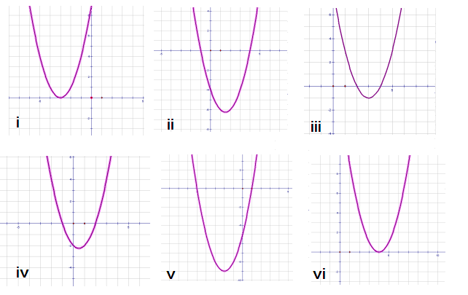
Key Question #3
- Directions: Factor each expression. Then find the roots of each equation.

a. $x^{2}+\text{7x}+\text{12}=0$

$\left(x + 3\right)\left(x + 4\right)$

x +3 = 0 and x + 4 = 0

x +3= 0 x + 4 = 0
x = -3 x = -4

Therefore, the roots of x = -4 and x = -3
b. $t^{2}+\text{6t}+8=0$
$\left(t + 2\right)\left(t + 4\right)$

x +2= 0 and x + 4 = 0

x +2= 0 x + 4 = 0
x = -2 x = -4
c. $\text{2}{\text{n}}^{2}\text{- 2n}-\text{24}=0$
$2\left(n -4\right)\left(n + 3\right)$
n-4=0 n+3=0
n=4 n=-3

d. $y^{2}\text{-11y}+\text{28}=0$
$\left(y -7\right)\left(y -4\right)$=0
Y=7 y=4
Key Question #3 (con’t)
- Directions: Solve each equation.

a. $x^{2}=\text{2x}+\text{48}$ = $factor\left(x^{2} - 2 x - 48\right)$
$\left(x -8\right)\left(x + 6\right)$=0
X=8 x=-6
b. $t^{2}+\text{5t}=\text{-6}$ $factor\left(t^{2} + 5 t + 6\right)$
$\left(t + 2\right)\left(t + 3\right)$=0
t=-2 t= -3
c. $x^{2}=\text{30-7x}$ $factor\left(x^{2} - 30 + 7 x\right)$
$\left(x -3\right)\left(x + 10\right)$ =0
X=3 x= -10
3. Directions: Determine all the values of n that satisfy the equation.

a. $\text{y }= {\text{n}}^{2}-\text{7n}+\text{12, when y}=2$
2=$n^{2}-7n+12$
$n^{2}-7n+10$
$\left(n -5\right)\left(n -2\right)$=0
n= 5 n=2
b. $\text{y }= {\text{n}}^{2}-\text{8n}+\text{16, when y}=4$
$factor\left(n^{2} - 8 n + 12\right)$
$\left(n -6\right)\left(n -2\right)$=0
n =6 n=2
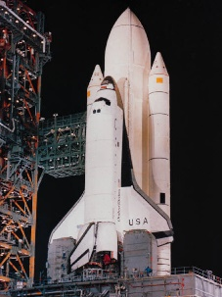
4. A model rocket is shot straight up from the roof of a school. The height at any time t is approximated by the model $h=-t^{2}+\text{3t}+\text{28}$, where h is the height in metres and t is the time in seconds. When does the rocket hit the ground?
$factor\left(- t^{2} + 3 t + 28\right)$
$-\left(t -7\right)\left(t + 4\right)$ =0
$t=-4$
$t=7$ The rocket hits the ground in 7 seconds.
- For each of the quadratic functions given below find the zeros and then state which graph it matches below.

a. $y=x^{2}-x-6$
$factor\left(x^{2} - x - 6\right)$
$\left(x -3\right)\left(x + 2\right)$=0
X=3 x=-2 matches graph (iii)
b. $y=x^{2}+3x-4$ $factor\left(x^{2} + 3 x - 4\right)$ $\left(x -1\right)\left(x + 4\right)$ x=1 x= -4 matches graph(ii)
c. $y=x^{2}-4x+4 factor\left(x^{2} - 4 x + 4\right)$ (x-2)(x-2) x=2 matches graph (i)
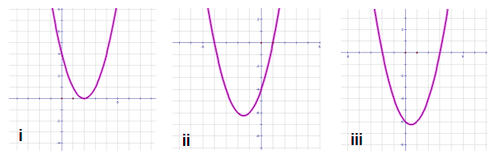

Support Questions

- Evaluate:

- (-11)⁰ =1 b. 5² = (5*5) =25 c. 81⁻¹=1/81 d. 15432⁰=1 e. 6⁻³=1/6*1/6*1/6 =1/216

f. $\frac{1}{2^{3}}$x 16^{-7 x 0} = $\frac{1}{8}$ x 1 =$\frac{1}{8}$
g. $\frac{1}{7^{2}}$= $\frac{1}{49}$

h. 25

- a. ${\left(\frac{2}{5}\right)}^{-6+(-3)}={\left(\frac{2}{5}\right)}^{-9}={\left(\frac{5}{2}\right)}^{9}$

b. (-21)⁻² ⁺⁽⁻³⁾ =(-21)⁻⁵ =$\frac{1}{(-21)^{5}}$
c. m^{-3 x 6} =m⁻¹⁸ = $\frac{1}{m^{18}}$

d. (3²a^{1 x 2}b^{2 x 2}c^{1 x 2}) = 9a²b⁴c²

e. (a^{-2 – 4})⁻² = a^{-6 x -2} = a¹²

f. $\frac{\left(7^{2} x -3\right)\left(m^{2x2+4}n^{-5x2+8}\right)}{\left(3 x-1\right)\left(m^{1+(-2)}n^{1+(-4)}\right)}=\frac{-147m^{8}n^{-2}}{-3m^{-1}n^{-3}}=-49m^{8-(-1)}n^{-2-(-3)}=-49m^{9}n^{1}$

Key Question #4
- Evaluate.
a. 3³ =3*3*3=27
b. (-2)⁵ (-2)* (-2)* (-2)* (-2)* (-2)= $-32$
c. (-1)³⁵ (-1)* (-1)* (-1)* (-1)…………….* (-1)=$-1$
d. 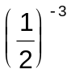 (2)^3=$8$
e. (-2)⁰ =1
g. 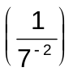 =7^2 =$7^{2}$ =49
h. 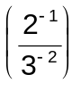 ( ½)/($\frac{1}{3^{2}}$) =(1/2)(1/9)
=$\frac{9}{2}$
- Simplify.
a. 7⁸ ÷ 7⁻² = $7^{8+2}$ =$282475249$
b. 11⁻⁵ x 11⁻³= ${11}^{-8}$ =
c.$\frac{1}{2^{-6}}$ x 2⁸ =$2^{6}$ *2⁸ = $2^{14}$ = $16384$
d. –(-2)⁰ x (-2)³ x (-2)⁻⁴ ÷ (-2)³
-[${\left(-2\right)}^{\begin{aligned}0+3-4-3 \\ \end{aligned}}$]
[ ${\left(-2\right)}^{-4}$]-1 =$\frac{1}{-2^{4}}$* -1 =0.0625
e. 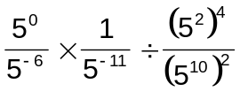
=${\left(5\right)}^{\begin{aligned}2*8 \\ \end{aligned}}$] =${\left(5\right)}^{\begin{aligned}8 \\ \end{aligned}}$] 5
=$\left(5^{0-8}*1^{-5x2+8}\right)$
=$5^{0}$*$5^{2}$*1*$5^{11}$/$5^{8}$*$5^{-20}$
$=5^{25}$
=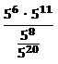
f. 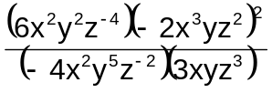
$$\frac{\left(6 x 4\right)\left(x^{2+3*2}y^{2+2}z^{-4+4}\right)}{\left(-4*3\right)\left(x^{2+1}y^{5+1}z^{-2+3}\right)}=\frac{24 {x^{8}{ y}^{4}}^{}z^{0}}{{-24x}^{3}y^{6}z^{1}}=-x^{5}y^{-2}z^{-1}$$
- Express each as a single power of 2.
- 2ª x 2^{b} x 2^{c}
= $2^{\begin{aligned}\left(a+b+c\right) \\ \end{aligned}}$

- 2^{a + b} x 2^{a – b}
=$2^{a+b+a-b}$
=$2^{2a}$
c. 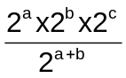
$2^{a+b+c-\left(a+b\right)}$
$2^{a+b+c-a-b}$ =$2^{c}$

Lesson 5

- Equations V = 4^{t} and y = 1.05^{x} are exponential equations because they are in the form y = Ab^{x}

- a. i) y = 5^{x} ii) y = ${\left(\frac{1}{5}\right)}^{x}$

x | y = ${\left(\frac{1}{5}\right)}^{x}$
-3 | $\frac{1}{5^{-3}}=5^{3}=$125
-2 | $\frac{1}{5^{-2}}=5^{2}=$25
-1 | $\frac{1}{5^{-1}}=5^{1}=$5
0 | 1
1 | $$\frac{1}{5}$$
2 | $$\frac{1}{25}$$
3 | $$\frac{1}{125}$$

x | y = 5^{x}
-3 | $$5^{-3}=\frac{1}{5^{3}}=\frac{1}{125}$$
-2 | $5^{-2}=\frac{1}{5^{2}}=\frac{1}{25}$
-1 | $$5^{-1}=\frac{1}{5}$$
0 | 1
1 | 5
2 | 25
3 | 125

b. i) y = 5^{x}
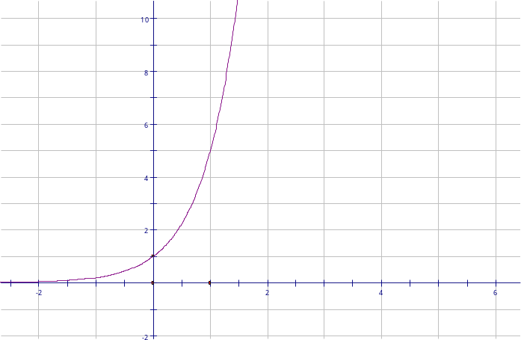
ii) y = ${\left(\frac{1}{5}\right)}^{x}$
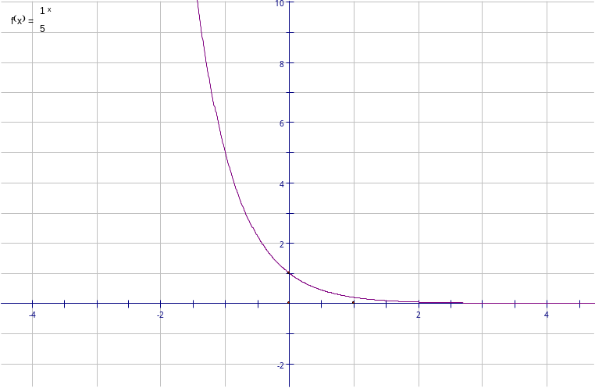
c. The graphs are similar because:
- they both go through (0, 1)
- Neither graph crosses the x-axis

The graphs are different because:
- y = 5^{x} goes up to the right and y = ${\left(\frac{1}{5}\right)}^{x}$ goes down to the right.

Key Question #5
- Which equations represent exponential functions? Explain.

Equations P = 5^{x} and A = P(1 + i)^{n} are exponential equations because they are in the form y = Ab^{x}

2. Make a table of values for the following exponential functions:
i) y = 4^{x}
ii) y = 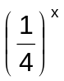
x | y = 4^{x}
-3 | $$4^{-3}=\frac{1}{4^{3}}=\frac{1}{64}$$
-2 | $4^{-2}=\frac{1}{4^{2}}=\frac{1}{16}$
-1 | $$4^{-1}=\frac{1}{4}$$
0 | 1
1 | 4
2 | 16
3 | 64
x | y = ${\left(\frac{1}{4}\right)}^{x}$
-3 | $\frac{1}{4^{-3}}=4^{3}=$64
-2 | $$\frac{1}{4^{-2}}=4^{2}=16$$
-1 | $$\frac{1}{4^{-1}}=4=4$$
0 | 1
1 | $$\frac{1}{4}$$
2 | $$\frac{1}{16}$$
3 | $$\frac{1}{64}$$

  - How are the values in each table related?
At zero they both yields value 1

  - Graph the functions in a)
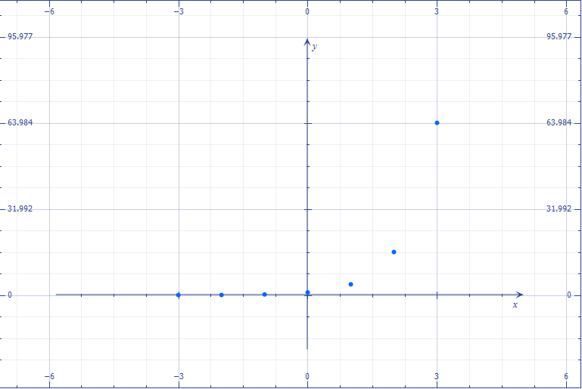

ii) y =
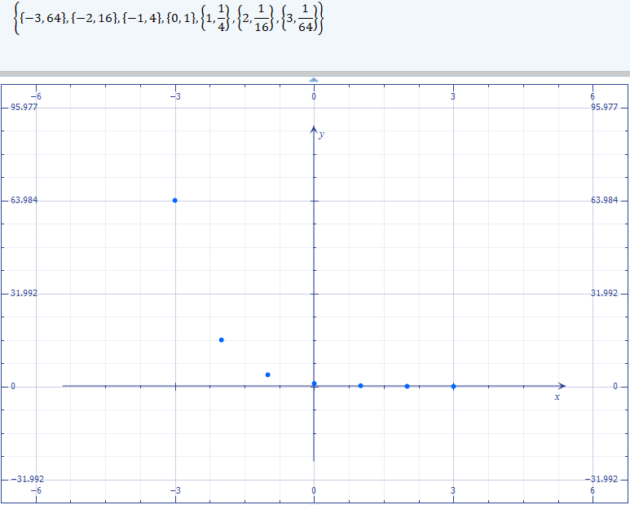

How are the graphs related?
Both graphs go through (0, 0)
Both graphs touches the x -axis but neither graph crosses the x-axis

